**Question 5**

Step 1: Step 1: Create a feature branch.



Step 2: Switch to the new branch.

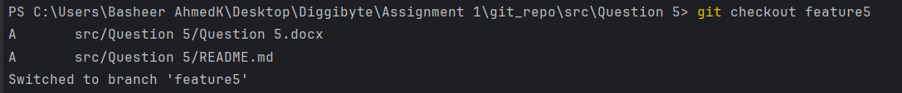

open the file and make some changes to it.

Add and commit the changes to the new branch.

open the same file and make some changes to it.

Add and commit the changes to the new branch.



open the same file and make some changes to it.

Add and commit the changes to the new branch.

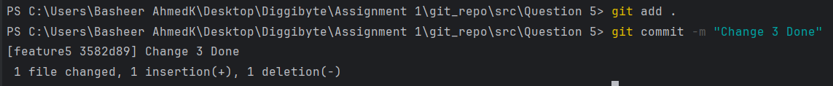

Step 3: Use the "git log" command to view the commit history and identify the commit to which you want to reset.

Here I want “Change 2 Done” that I want to reset and its hash is “3cbfdee”

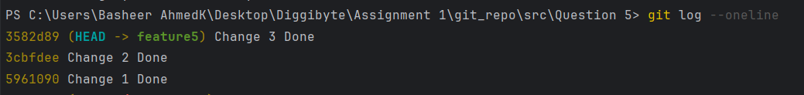

Step 4: Use the "git reset" command followed by the desired reset type and the commit hash



Step 5: Verify that the reset was successful by using the "git log" command again.



Step 6: Use the "git log" command to view the commit history and identify the commit that you want to reverse.

Here I want to revert “Change 1 Done” and its hash is “5961090”



Step 7: Use the "git revert" command followed by the commit hash or reference to which you want to revert. (Hint: git revert <commit hash>)

Step 8: Verify that the revert was successful by using the "git log" command again.

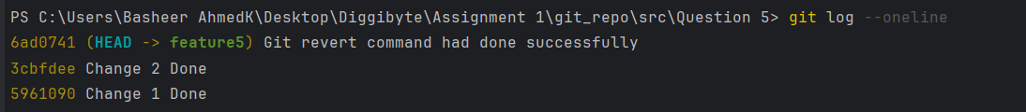

Note: Identify the difference between git log after git reset and git revert.